

|  |  |  |  |
| --- | --- | --- | --- |
|  | Our family newsletter |  |  |
| December 20XX |
| family baking  Add caption here  Happy holidays from our family to yours!  Holiday newsletters are a great way to keep the people closest to you updated on your family's life. It's also a fun way to share holiday greetings or write about your past year's experiences. To start, let each of your family write down their own articles in the newsletter. Add photographs from family vacations. Think about what you would tell your family and friends if you could see them.   A family newsletter is also a fun activity to do as a family. Everyone feels included when you share memories with each other. Sit down and talk about the important things that happened in the past year. Also, think about who's reading your newsletter. What would your friends or distant relatives most want to hear about? Write down your ideas and then organize your list into categories. | Special events   * Add a special highlight from your family’s life * Add a special highlight from your family’s life * Add a special highlight from your family’s life   family dancing in the living room  Add caption here  “A favorite family phrase or slogan can go here.” |
| Page 1 | | | |



|  |  |  |  |
| --- | --- | --- | --- |
|  |  |  |  |
| Adding pictures to your newsletter  Pictures of your family trips or special events can bring your newsletter to life. Once you've chosen a picture, place it close to the information. Be sure to put the caption of the image near the image. Want to use online images in your newsletter? Find thousands of images online to download and insert into your newsletter.    To change the pictures in this newsletter to your own, select the image you wish to change. Go to **Insert**, **Pictures**, and then select either **Pictures**or **Online Pictures**. Locate the image you want and double-click it. The new picture will add to the existing text box for easy positioning.  Tip: Borders may not show on text boxes that contain images or text. Before you add anything else, make sure it's placed within a text box. Pictures of your family trips or special events can bring your newsletter to life. Once you've chosen a picture, place it close to the information. Be sure to put the caption of the image near the image.  family dancing in living room  Add caption here |
| woman reading to daughter  Add caption here  Adding your own message  Add a simple greeting, poem, or your children's artwork on the back of your family's newsletter. Make sure that it is festive and eye-catching because it'll be the first thing seen.   You can add your own artwork to the back of a family newsletter by scanning in a drawing or a photograph.  Add a simple greeting, poem, or your children's artwork on the back of your family's newsletter. Make sure that it is festive and eye-catching because it'll be the first thing seen. |
| Page 2 | | | |

|  |  |  |
| --- | --- | --- |
| family baking | | |
| Add caption here | | |
| woman reading to daughter | | family dancing in living room |
| Add caption here | | Add caption here |
| woman and daughter in living room | family baking | |
| Add caption here | Add caption here | |
| Page 3 | | |

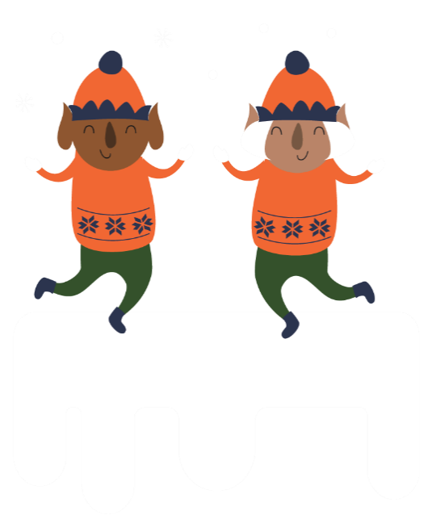

|  |  |  |  |
| --- | --- | --- | --- |
|  |  |  |  |
|  | Write with ease using Editor  We’ve added a new feature in Word that can help you elevate your writing. You've probably used tools like spell checker to look for spelling mistakes, and Editor can help you with that too. In fact, anyone can use Editor for grammar and spelling help across Word, Outlook.com, and the web.   Editor is free with a Microsoft sign-in, but Microsoft 365 subscribers have access to advanced grammar and style refinements. When you’re a subscriber, you'll unlock the ability to scan your writing for conciseness, formal language, vocabulary suggestions, and more.  “To catch the reader’s attention, place an interesting sentence or quote from the story here.”  Use Editor to flag for wordiness, conjunction overuse, passive voice, double negatives, and other issues. Correcting style issues can sharpen your writing and make it easier to understand.   Pictures of your family trips or special events can bring your newsletter to life. Once you've chosen a picture, place it close to the information. Be sure to put the caption of the image near the image. Want to use online images in your newsletter? Find thousands of images online to download and insert into your newsletter.  family dancing in living room  Add caption here |
| Adding upcoming events  woman and daughter in living room  Add caption here  A great way to add content to this newsletter is to include a calendar of upcoming events. You can also add a special memory that your family shares.   Transcribe the words of a song or a poem onto the back of your newsletter. With a little creativity, your holiday newsletter can be a great way to say, "Season's Greetings!"  A great way to add content to this newsletter is to include a calendar of upcoming events. You can also add a special memory that your family shares. |
| Page 4 | | | |